POE Part 2
CLDV6211
Student Number: ST10493664
Name: Reabetswe Tebogo Fafudi
Module Code: CLDV6211
Class Group: Group 4
Table of Contents

Project Description 2
Part 2A – Integrate Local Blob Storage (Azurite) 3
Screenshots 3
Azurite Running in CMD 3
Microsoft Azure Storage Explorer 3
Venues Page – With Image Upload Functionality 3
Venues Page Updated Successfully With Uploaded Image 4
Part 2B 5
Part 2C 5
Part 2D 5
Part 2E 5
References 5

Project Description
GitHub Repo Link (Main): https://github.com/reabetswef/ST10493664-CLDV6211-POE.git
GitHub Repo Link (Organisation):
YouTube Video Link:

Part 2A – Integrate Local Blob Storage (Azurite)

Screenshots

Azurite Running in CMD
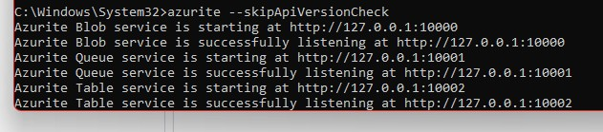

Microsoft Azure Storage Explorer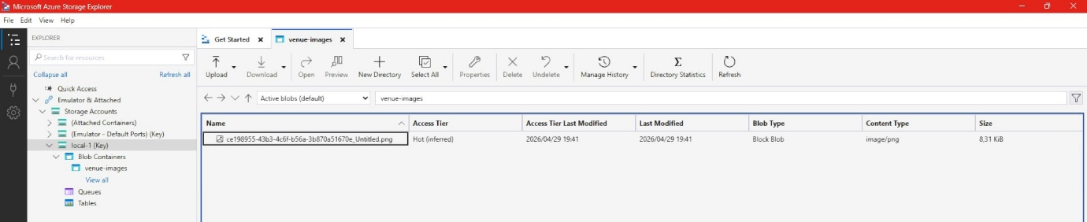

Venues Page – With Image Upload Functionality
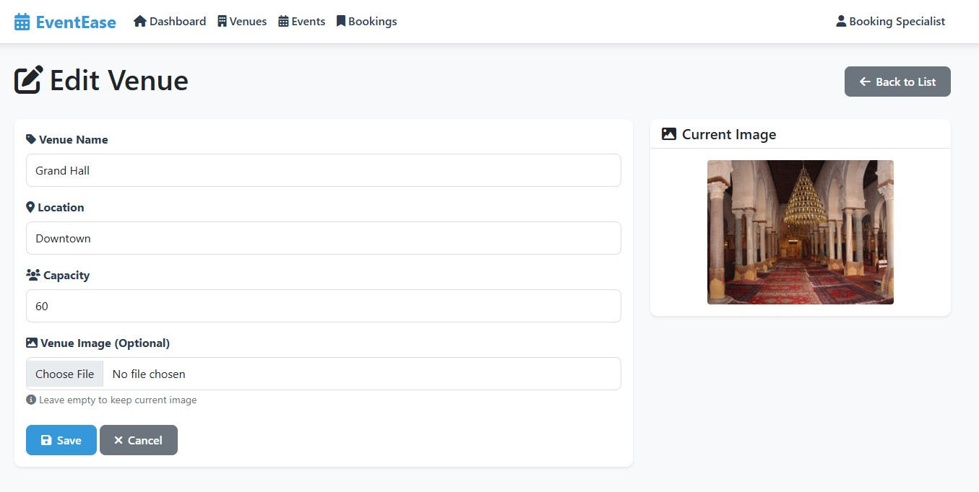

Venues Page Updated Successfully With Uploaded Image
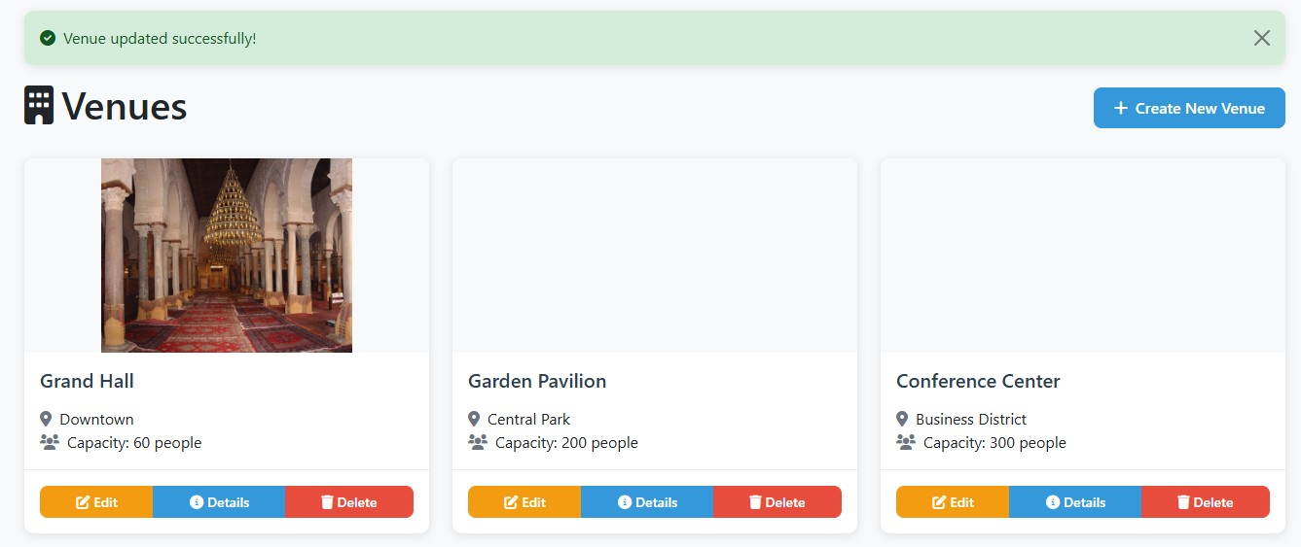

Part 2B

Part 2C

Part 2D

Part 2E

References

